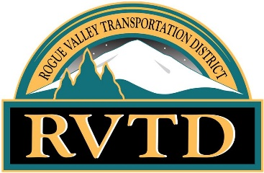
ROGUE VALLEY TRANSPORTATION DISTRICT
ACCESSIBLE WORK GROUP MEETING
MARCH 15TH, 2023 3:00PM TO 4:00PM VIA ZOOM VIDEO CONFERENCE
Public notice is posted at RVTD.org
AGENDA
TIME | SPEAKER | MATERIALS | TOPIC
5 MINS | EVERYONE |  | WELCOME
2 MINS | MARIA |  | ROLL CALL
3 MINS | GEORGE |  | REVIEW AND APPROVE NOVEMBER 16, 2022 MINUTES
10 MINS | TIM |  | AWG APPLICATIONS FOR POSSIBLE NEW MEMBERS
10 MINS | TIM |  | NEW SOFTWARE “QRYDE”
10 MINS | TIM |  | EXPECTED CHANGES IN FARE FOR NEXT FISCAL
5 MINS | EVERYONE |  | 2023 AWG MEETING DATES: DISCUSS DURING MEETING
10 MINS | EVERYONE |  | AGENDA ITEMS FOR NEXT MEETING
5 MINS | EVERYONE |  | OTHER COMMENTS, QUESTIONS OR CONCERNS
4:00PM | GEORGE |  | ADJOURNMENT

The facility used for this meeting is wheelchair accessible. If you require any special physical or language accommodations, including alternative formats of printed materials, please contact RVTD’s Administrative office as far in advance of the meeting as possible and no later than 48 hours prior to the meeting. To request these arrangements, please call 541-842-2080 (voice) or 7-1-1 (TTY, through Oregon Relay, for persons with hearing impairments).

