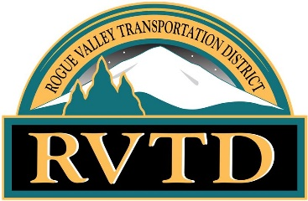
ROGUE VALLEY TRANSPORTATION DISTRICT
ACCESSIBLE WORK GROUP MEETING
JULY 19TH, 2023 3:00PM TO 4:00PM VIA ZOOM VIDEO CONFERENCE
Public notice is posted at RVTD.org
AGENDA
TIME | SPEAKER | MATERIALS | TOPIC
5 MINS | EVERYONE |  | WELCOME
5 MINS | MARIA |  | ROLL CALL
5 MINS | GEORGE |  | REVIEW AND APPROVE MARCH 15, 2023 & NOVEMBER 16, 2022, MINUTES
10 MINS | NEW MEMBER |  | NEW AWG APPLICANT
10 MINS | TIM |  | NEW SOFTWARE “QRYDE”
5 MINS | TIM |  | NEW FISCAL YEAR
5 MINS | TIM |  | STATS AND GRAPHS
5 MINS | EVERYONE |  | 2023 AWG MEETING DATES: OCTOBER 18TH & DECEMBER 20TH
0 MINS |  |  | NEXT AWG MEETING DATE: OCTOBER 18TH
5 MINS | EVERYONE |  | AGENDA ITEMS FOR THE NEXT MEETING
5 MINS | EVERYONE |  | OTHER COMMENTS, QUESTIONS OR CONCERNS
4:00 PM | GEORGE |  | ADJOURNMENT

The facility used for this meeting is wheelchair accessible. If you require any special physical or language accommodations, including alternative formats of printed materials, please contact RVTD’s Administrative office as far in advance of the meeting as possible and no later than 48 hours prior to the meeting. To request these arrangements, please call 541-842-2080 (voice) or 7-1-1 (TTY, through Oregon Relay, for persons with hearing impairments).

